+1 (945)333-1961
sanathkumaraitha1@gmail.com www.linkedin.com/in/sanath-kumar-aitha-37aa67203
PROFESSIONAL SUMMARY:
- Having around 8 years of relevant experience in the Force.com platform and Salesforce.com playing multiple roles, acting as a fulcrum between business and implementation, depending on need -Administrator, Developer.
- Proven track record of delivering Sales Cloud, Service Cloud, Experience Cloud, and custom cloud implementations to drive process efficiency and customer engagement.
- Hands-on experience developing Lightning Web Components (LWC), Apex Classes, Triggers, and Visualforce pages for scalable business solutions.
- Expertise in OmniStudio, including OmniScripts, Data Raptors, and Integration Procedures to build flexible and reusable Ul and service components.
- Proficient in developing and consuming RESTful and SOAP APIs, including security mechanisms such as Auth 2.0, JWT, and Named Credentials for external integrations.
- Successfully integrated Salesforce with legacy systems, CRMs, databases, and middleware tools using custom APls and platform events.
- Designed and developed unlocked Salesforce packages for modular deployment, reducing time-to-market and improving maintainability.
- Strong understanding of Salesforce data architecture, SOQL/SOSL, and handling of large data volumes through batch Apex and asynchronous jobs.
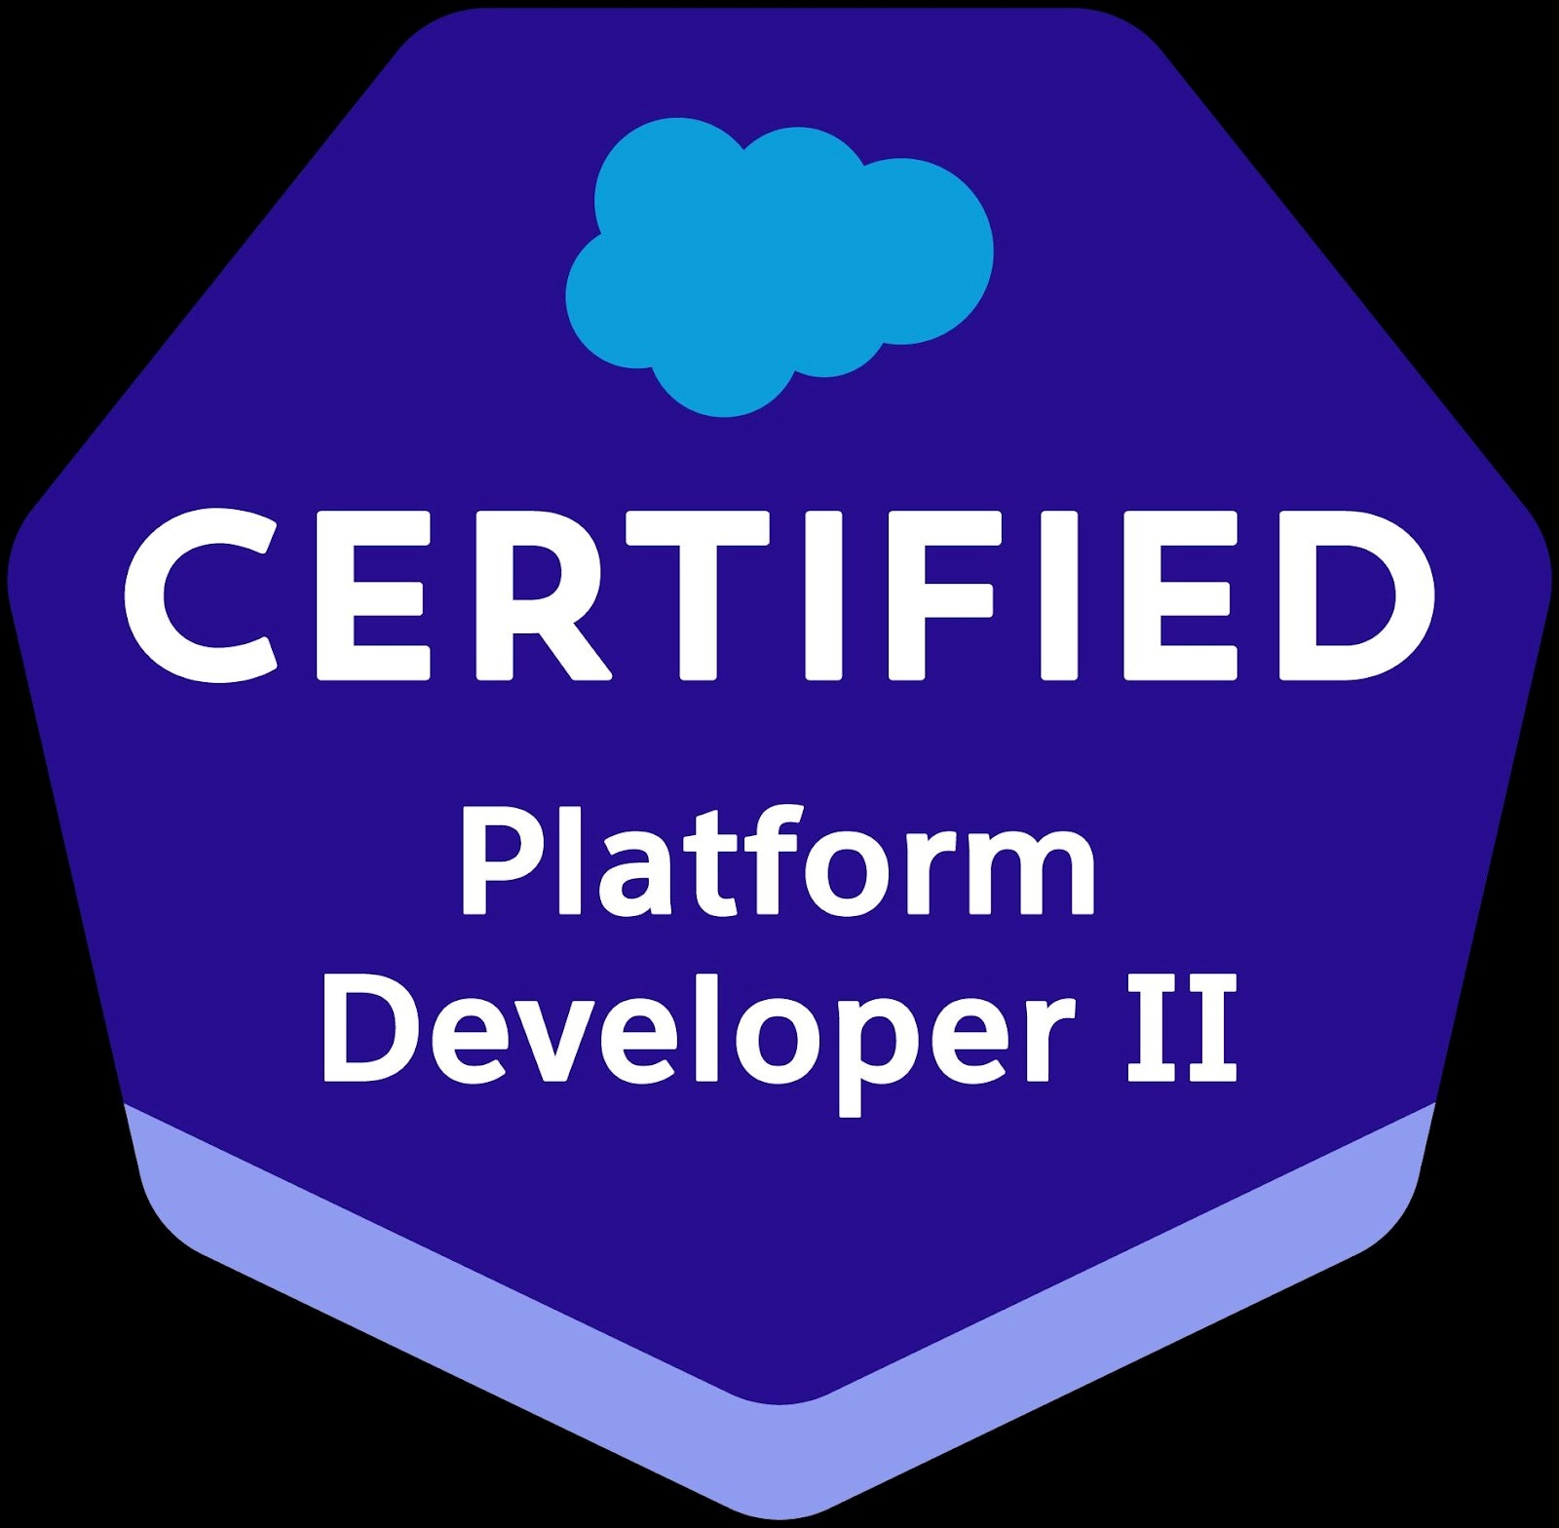
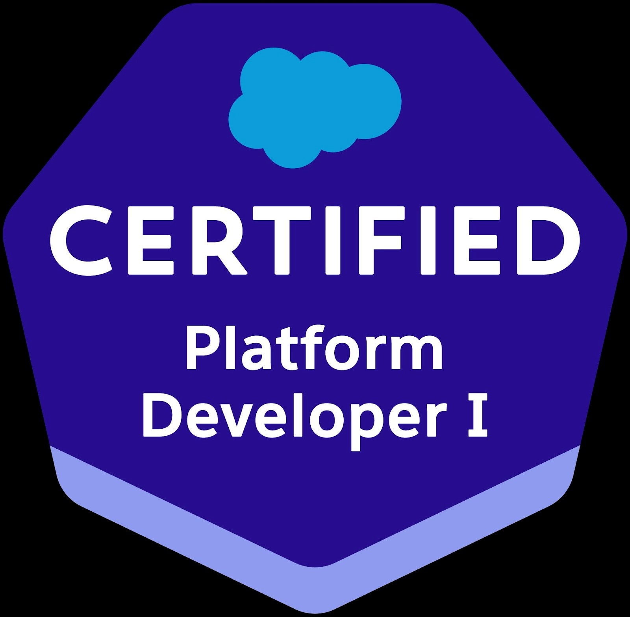
- Automated critical business processes using Flows, Process Builder, and Apex triggers, resulting in up to 40% operational time savings.

AITHA SANATH KUMAR (Senior Salesforce Developer)
- Worked with mainframe integration, real-time claim management, and financial data synchronization across systems in large-scale enterprise applications.
- Experience in CI/CD using Git, GitLab, Jenkins, and Salesforce DX for version control, automated testing, and deployment pipelines.
- Conducted static code analysis and implemented secure coding practices using Checkmarx and manual vulnerability mitigation techniques.
- Delivered Behavior-Driven Development (BDD) automation scripts and GitLab CI/CD reports to support continuous testing and delivery.
- Expert in conducting system health checks, monitoring scheduled jobs, and proactively resolving integration and performance issues.
- Led end-to-end development of new components and features from design through deployment and post-release support.
- Configured Salesforce applications, including profiles, roles, sharing rules, page layouts, and validation rules to enforce security and business logic.
- Supported User Acceptance Testing (UAT) and created deployment documentation such as EOT (Evidence of Testing) and training guides.
- Played a key role in Agile/Scrum teams, actively participating in sprint planning, PI sessions, retrospectives, and daily stand-ups.
- Delivered impactful Salesforce solutions for home loan origination, claim adjudication, customer service management, and solar financing platforms.
- Trained and mentored junior developers and QA engineers on Salesforce best practices, deployment strategies, and component design.
Migrated legacy Visualforce components to Lightning Experience and built modern, responsive Ul with LWC and SLDS.
- Utilized Salesforce Health Cloud, Financial Services Cloud (FSC), and Marketing Cloud in cross-cloud initiatives.
- Worked with Git-based branching strategies, Jira ticketing systems, and Confluence documentation in regulated project environments.
- Built robust unit tests with >90% code coverage, ensuring stability during Salesforce upgrades and deployments.
- Proven ability to deliver secure, scalable, and maintainable Salesforce solutions in high-stakes, regulated industries such as insurance and finance.
CATEGORY | SKILLSET
Salesforce  Technologies | Salesforce CRM, LWC, Aura Components, FSL, CPQ, SOAP & REST Integrations, Data  Migrations, MuleSoft, Salesforce SFA, Apex Triggers, SOQL, SAQL, Visualforce  Pages/Components, Web Services, Workflow & Approvals, Dashboards, Custom Objects,  Email Templates, Email Alerts, Validation Rules, Static Resources, Reports & Dashboards,  Batch Apex, Sharing Rules, Group, Roles & Profiles, Lightning Components, Lightning Process  Builder, User Management, Case Management, Data Management, Opportunity  Management, Campaign Management, Change Set, Continuous Production Deployment
Salesforce Clouds | Sales Cloud, Service Cloud, Marketing Cloud, Commerce Cloud, Analytics Cloud, Non-profit Cloud, Experience Cloud
Tools | Eclipse, Force.com Eclipse IDE Plug-in, Data Loader, Workbench, OwnBackup, DocuSign,  Conga, Jenkins, Workspace, JIRA, Confluence, Excel Connector, Platform (Sandbox and Production), VS Code, GitHub, HPSM, Salesforce Inspector
Databases | MySQL (5.1), Oracle (11g, 12c), Kenan Arbor
Web Services | WSDL, SOAP, REST API
Languages | Apex, C, C++, Java, JavaScript, UML, HTML, XML
Testing Tools | Katalon, Sandbox UAT, Bug Tracing, QTP, QC, LoadRunner

Client: Vizio Inc Mar 2025 – Present
Role: Senior Salesforce Developer Location: Texas, United States.
Roles & Responsibilities:
- Collaborated with product owners to analyze business requirements and documented them using VersionOne, OneNote, and SharePoint.
- Participated in Program Increment (PI) planning to align features, development sprints, testing phases, and production releases.
- Authored complex business requirements and design documents following Agile methodology and SAFe practices.
- Coordinated with architects to modernize legacy codebases and design scalable Salesforce solutions.
- Conducted in-depth data analysis to validate compliance with internal audit and security regulations.
- Implemented Salesforce CPQ workflows for quote generation, integrating configuration and pricing logic within existing Sales Cloud processes.
- Built custom approval processes for discount thresholds using Flow and Apex triggers.
- Designed dynamic Uls using Salesforce Lightning Web Components (LWC), HTML5, CSS3, and JavaScript
- Developed Apex classes, batch processes, triggers, and schedulers to handle complex business logic.
- Built and consumed RESTful and SOAP-based APIs to enable real-time and batch integrations with third-party systems.
- Designed APIs for quote and order data exchange between Salesforce CPQ and downstream systems.
- Leveraged Spring Tool Suite (STS) for Apex coding, debugging, and metadata deployment management.
- Developed and executed Behavior-Driven Development (BDD) scripts and integrated reports via Gitlab CV/CD Pipelines.
- Integrated CPQ data with ERP/Billing systems for seamless order synchronization and revenue recognition.
- Created detailed EOT (Evidence of Testing) documentation to support UAT sign-off and production deployment.
- Delivered end-to-end development of modular Salesforce components, improving reusability and maintainability.
- Wrote efficient SOQL/SOSL queries and implemented governor limit-optimized data access logic.
- Diagnosed and resolved LWC, Apex, and integration-level bugs in coordination with QA and DevOps teams.
- Optimized CPQ performance by refactoring bundle configurations and automating renewal processes.
- Implemented unit tests with >85% code coverage to ensure robust application functionality.
- Configured Named Credentials, Auth 2.0 flows, and JWT for secure external integrations.
- Used Git and GitLab for version control, branching, and continuous integration workflows.
- Actively participated in Agile ceremonies: daily stand-ups, sprint reviews, retrospectives, and backlog grooming.
- Supported production deployments, post-release validation, and defect triage to ensure high system uptime.
- Documented technical specifications, solution architecture, deployment plans, and user stories.
- Assisted in performance tuning of Apex code and LWC to enhance application response times.
- Provided mentorship to junior developers on Salesforce DX, Apex standards, and secure development practices.
Environment: Sales Cloud, Service Cloud, Experience Cloud, Apex, Visualforce, JavaScript, HTML5, CSS3, SOQL,
SOSL, Lightning Web Components (LWC), Spring Tool Suite (STS), SLDS, RESTful APIs, SOAP APis, Named Credentials, OAuth 2.0, JWT, Git, GitLab, GitLab CI/CD Pipelines, VersionOne, Checkmarx, BDD Framework, EOT Docs, JIRA, OneNote, SharePoint, Salesforce DX, Change Sets, Static Code Analysis Tools, Agile, Scrum, SAFe.
Client: UNITED BREWERIES Dec 2022 – Feb 2025
Role: Lead Salesforce Developer
Company: Persistent Systems
Description: United Breweries puts the power to sell smarter in salespeople’s hands. In India, one out of every two bottles of beer sold comes from United Breweries. That’s a healthy market share for the company also known as UBL. Nevertheless, maintaining a prominent brand position within India’s liquor outlets isn’t easy. In the country’s highly regulated alcoholic beverage industry, selling doesn’t occur in the classical sense. Instead, Government entities control the route into most markets with retailers required to purchase stock from Government warehouses.
Roles & Responsibilities:
- Developed a website with the help of HTML, CSS, JavaScript, and JQuery.
- With JavaScript and JQuery controlled the data for client-side validations.
Collaborated on the implementation of Salesforce CPQ to streamline quote-to-cash workflows.
- Assisted in configuring pricing rules, product bundles, and guided selling experiences.
- Gained exposure to Revenue Cloud Billing (RCB) and Revenue Cloud Analytics (RCA) for subscription and billing processes.
- Used Xampp Server to interact with the database.
- Collaborated on full-cycle Salesforce CPQ implementation, streamlining quote-to-cash operations across multiple product lines.
- Managed database operations like managing the connections with SQL servers.
- Built Lightning Component Tab for Salesforce1Custom Applications in Lightning Experience.
- Involved in Salesforce.com Application Setup activities and customized the apps to match the functional needs of the organization.
- Configured bundled products, guided selling flows, and custom discounting logic using Price Rules and Lookup Queries.
- Reduced manual processes by 40% through automation using Flows and Apex triggers.
- Migrated Legacy Salesforce Classic components to Lightning experience.
- Interacted with various business team members to gather the requirements and documented the requirements.
- Designed and developed SFA based Application on the Force.com Platform in the Salesforce.com environment with Apex programming language at the backend and Visualforce pages as the user interface.
- Collaborated with finance and operations to align CPQ and ERP data models, ensuring billing consistency.
- Developed various Custom Objects, Tabs, Entity-Relationship data models, validation rules, Components, and Visualforce Pages.
- Responsible for customizing custom fields, page layouts, Custom Settings, Profile Settings, Record Types, Visualforce pages, SOQL, SOSL, and formula fields for various Standard and Custom Objects.
- Created the Batch Apex, Schedule Apex, Triggers, and Workflows for Email Alerts and Field Updates
- Developed Apex Classes, Controller Classes, and Apex Triggers for various functional needs in the application.
- Supported data migration of products, price books, and contracts into CPQ environment.
- Created Custom Settings for Auto Population of data and also for controlling Triggers Based on Users or Profiles.
- With JavaScript and JQuery controlled the data for client-side validations.
- Used Xampp Server to interact with the database.
- Managed database operations like managing the connections with SQL server.
Environment: Force.com, Salesforce CRM, Lightning, APEX, Visual Force Pages, workflow, validation rules, SOQL, SOSL, report, dashboard, JavaScript, HTML, CSS, JQuery, Jira, Github, Copado, LWC, Apex Triggers.
Client: BCCL Nov 2017 – Dec 2022
Role: Salesforce/Lightning Developer
Company: Gaman software Solutions
Location: Hyderabad, India
Description: Bennett, Coleman & Co Ltd serves up newsworthy customer experiences with Salesforce. Bennett, Coleman & Co Ltd (BCCL) — also known as the Times Group — powers some of India’s most iconic brands across publishing, television, the internet, and radio. BCCL needed a proper CRM framework with well-defined processes aligned to business objectives. The company evaluated several CRM solutions, and Salesforce emerged as the top choice.
Roles & Responsibilities:
- Developed a website with the help of HTML, CSS, JavaScript, and JQuery.
- Built Lightning Component Tab for Salesforce1Custom Applications in Lightning Experience.
- Involved in Salesforce.com Application Setup activities and customized the apps to match the functional needs of the organization.
Interacted with various business team members to gather the requirements and documented the requirements.
- Designed and developed SFA based Application on the Force.com Platform in the Salesforce.com environment with Apex programming language at the backend and Visualforce pages as the user interface.
- Developed various Custom Objects, Tabs, Entity-Relationship data models, validation rules, Components, and Visualforce Pages.
- Responsible for customizing custom fields, page layouts, Custom Settings, Profile Settings, Record Types, Visualforce pages, SOQL, SOSL, and formula fields for various Standard and Custom Objects.
- Created the Batch Apex, Schedule Apex, Triggers, and Workflows for Email Alerts and Field Updates.
- Developed Apex Classes, Controller Classes, and Apex Triggers for various functional needs in the application.
- Created Custom Settings for Auto Population of data and also for controlling Triggers Based on Users or Profiles.
Environment: Force.com, Salesforce CRM, Lightning, Marketing Cloud, REST API, SOAP, Workflow Rules, SOQL,
Git, Github, Jira
EDUCATIONAL QUALIFICATION:
Bachelor Degree College in Computer Science SIDDARTHA DEGREE COLLEGE In Kakatiya University with 76%

